PHYS 563 HW #4

Name: Wen-Hua Wu

ID: S01470274

Email: [aw106@rice.edu](mailto:aw106@rice.edu)

Problem 1

We plotted the potential functions with python and have the following graph.

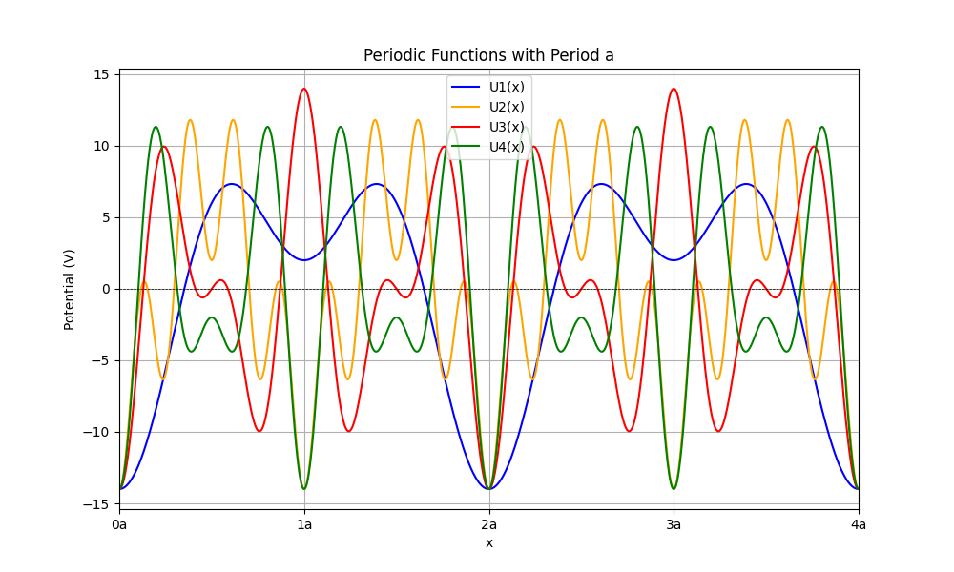

We can see clearly that U2, U4 are periodic function with period of a,

$$U_{2}\left(x+a\right)=U_{2}\left(x\right),U_{4}\left(x+a\right)=U_{4}\left(x\right)$$

But U1 and U3 have a larger period of 2a.

The reason is that U2 and U4 only have even integers multiplied with $πx/a$ in their cosine functions, and we know that $cos⁡(n×\frac{2πa}{a})=1$, so after a period of a, U2 and U4 can return to the original value.

But for U1 and U3, they have odd numbers integers multiplied with $πx/a$ in their cosine functions, which will have a larger period of 2a.

And since the one dimensional chain has a lattice constant of a, its potential must also have a period of a.

Thus only U2 and U4 satisfy the condition.

Problem 2b

Here we set $a=20 Å$, and $g=0.1eV×a$, $g=0$ (free electron case). We plotted the first three bands of the confined case ($g=0.1eV×a$) and free electron case ($g=0$).

We can see that the confined case have significant band gaps near the Brillioun Zone edge while the free electron case has continuous dispersion curve following the free-electron Hamiltonian:

$$E=H=\frac{ℏ^{2}k^{2}}{2m_{e}}$$

